**Result and Analysis**

* Although each of the three research methods—systematic literature reviews (SLR), interviews, and surveys—has advantages and disadvantages of its own, surveys are the best way to examine how social media affects mental health.

SLR entails combining previous studies to find trends, patterns, and gaps. Although it offers a thorough theoretical framework, it is dependent on secondary data and is unable to get contextually specific, real-time insights from the target audience.

In-depth qualitative data from interviews enables a thorough examination of each person's unique experiences. However, they take a lot of time, have a reduced scope because of the smaller sample sizes, and can add bias from participant responses or interviewer influence.

On the other hand, surveys balance specificity with breadth. By gathering numerical information from a sizable, heterogeneous group of respondents, surveys offer statistically meaningful information about social media usage trends and how they relate to mental health. They encourage candid input, particularly on delicate subjects like mental health, and are effective, economical, and enable anonymised responses.

Surveys are the most effective approach for this study because they provide actionable data to efficiently address the research objectives and suggest solutions by directly capturing the behavior, experiences, and attitudes of the target audience.

* Because it combines the advantages of quantitative data collecting with sophisticated analytical skills, the integration of surveys and Weka tools is important in data-driven research. Large-scale, varied datasets can be directly gathered from participants through surveys, offering practical insights on attitudes and behaviors like how social media affects mental health. Weka improves on this by using machine learning algorithms to find trends, categorize results, and uncover patterns in the dataset. This combination guarantees a thorough analysis, turning unprocessed survey data into knowledge that can be put to use. This is essential for confirming the goals of the study and putting forward workable, evidence-based solution.  
  According to the poll results, bad experiences like cyberbullying are closely associated with high follower counts and excessive social media usage. Younger people are most impacted, especially those between the ages of 17 and 29, who use platforms more regularly. This suggests that interventions that are specifically designed to lessen exposure to negative online behaviors while promoting a healthier digital environment are desperately needed.  
  I suggest a Personalized Digital Wellness Assistant (PDWA), an AI-powered program that is integrated into social media platforms to address this real-world issue. It encourages positive online conduct and protects mental health. The remedy consists of Behavioral monitoring keeps tabs on social media usage trends (such as hours spent and interactions with content) and notifies users when they surpass acceptable limits.

# Accuracy and Verification

The Weka classifier, weka.classifiers.rules, was used to construct the Decision Table model.Feature selection (Best First search) is enabled in the DecisionTable. 10-fold cross-validation was the test mode employed, guaranteeing the model's evaluation's resilience.

#Decisssion Tree

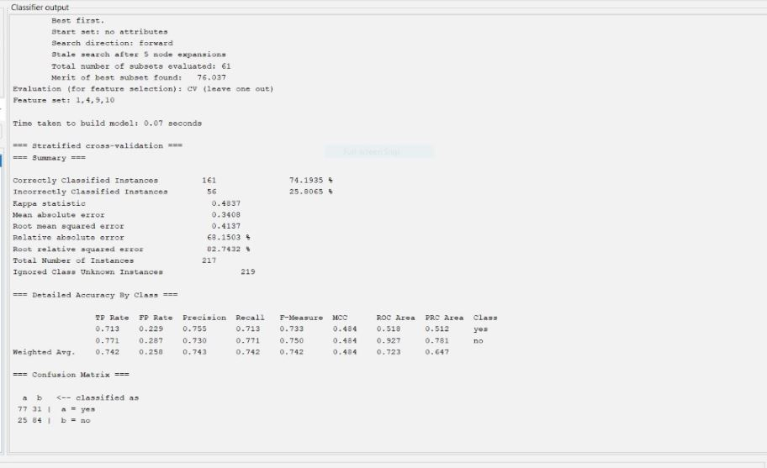

Decisssion Tree

The attached image displays the classifier evaluation results for a model trained using a decision tree with feature selection. Important points to note are:

Out of 217 occurrences, 161 (74.1935%) were correctly classified, whereas 56 (25.8065%) were wrongly classified.The model predictions and actual results show a moderate degree of agreement, as indicated by the kappa statistic of 0.4874.A mean absolute error of 0.4307, a root mean squared error of 0.4131, and a relative absolute error of 62.1503% are important error metrics.

Confusion matrix:

|  |  |  |
| --- | --- | --- |
| Classifie as | Yes(a) | No(b) |
| Actual Yes(a) | 77 | 25 |
| Actual No(b) | 84 | 31 |

#KStar

This output shows the evaluation metrics of a KStar classification model built using Weka. Let's break down the results:

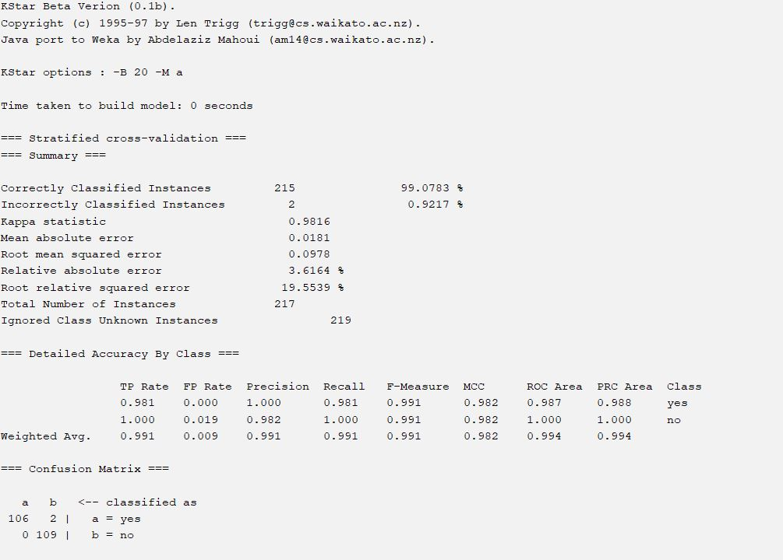

This output shows the evaluation metrics of a KStar classification model built using Weka. Let's break down the results:

The KStar classification model's output is displayed in the submitted image. The following are important details:

Just two (0.92%) of the 217 cases were misclassified, while 215 (99.08%) were correctly classified.

With a kappa statistic of 0.9816, the model demonstrated a high degree of agreement between predictions and actual results.

The mean absolute error and the root mean squared error are also extremely low at 0.0181 and 0.0978, respectively.

High classification performance is demonstrated by the weighted average F-measure of 0.991 and the overall ROC Area of 0.994.

Strong performance in both classes, with few misclassifications, is shown by the confusion matrix.

Confusion Matrix

|  |  |  |
| --- | --- | --- |
| Classifie as | Yes(a) | No(b) |
| Actual Yes(a) | 106 | 2 |
| Actual No(b) | 0 | 109 |

#LMT

Here's a summary of the provided machine learning model evaluation metrics:

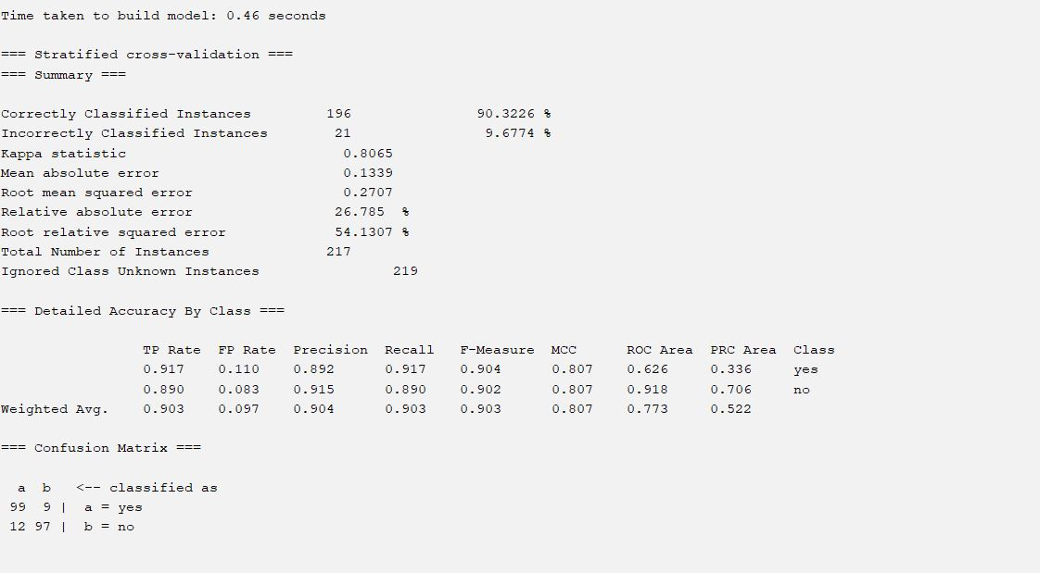

LMT

21 (9.68%) of the 217 cases were misclassified, whilst 196 (90.32%) were correctly classified.

With a kappa statistic of 0.8065, the model demonstrated a high degree of agreement between predictions and results.

With a mean absolute error of 0.1339 and a root mean squared error of 0.2707, the error metrics are minimal.

Good classification performance is indicated by the weighted average F-measure of 0.903 and the overall ROC area of 0.773.

Confusion Matrix

|  |  |  |
| --- | --- | --- |
| Classifie as | Yes(a) | No(b) |
| Actual Yes(a) | 99 | 9 |
| Actual No(b) | 12 | 97 |

Random Forest

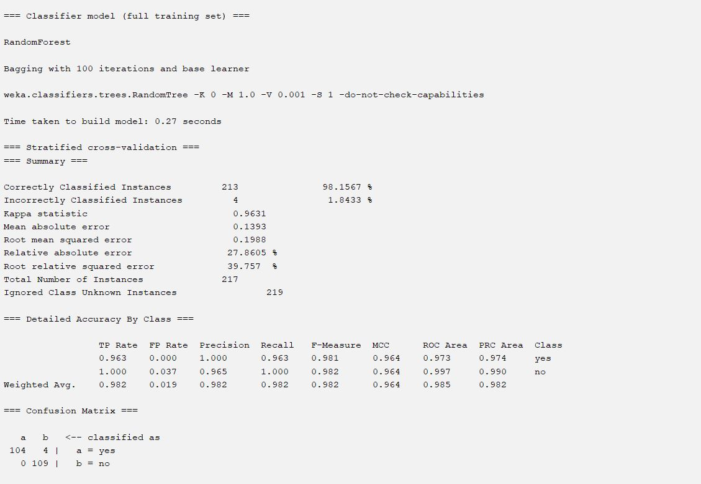

Random Forest

The model is a RandomTree base learner and a RandomForest classifier with 100 iterations. The accuracy on a stratified cross-validation test set was 98.15%, and it was constructed in 0.27 seconds. The model accurately categorized 104 out of 108 positive instances (yes) and 109 out of 109 negative instances (no), according to the confusion matrix. Overall, the performance is good, with low error rates and great precision.

Confusion Matrix

|  |  |  |
| --- | --- | --- |
| Classifie as | Yes(a) | No(b) |
| Actual Yes(a) | 104 | 4 |
| Actual No(b) | 0 | 109 |

Random Tree

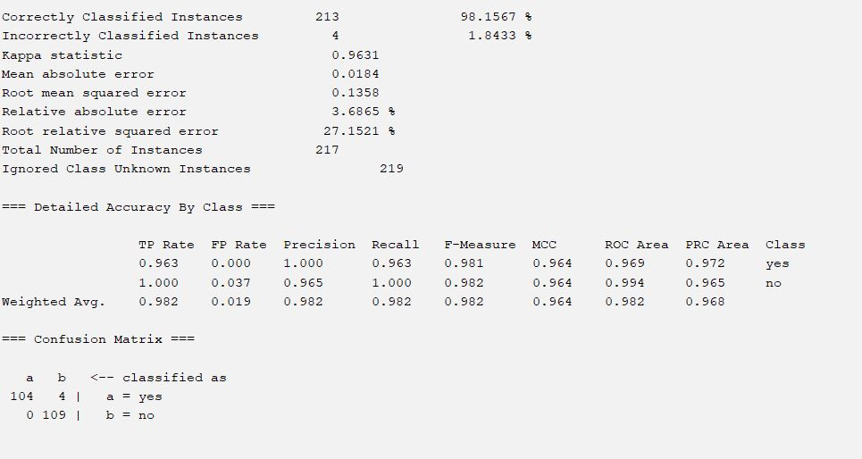

The model is a RandomTree base learner and a RandomForest classifier with 100 iterations. The accuracy on a stratified cross-validation test set was 98.15%, and it was constructed in 0.27 seconds. The model accurately categorized 104 out of 108 positive instances (yes) and 109 out of 109 negative instances (no), according to the confusion matrix. Overall, the performance is good, with low error rates and great precision.

Confusion Matrix

|  |  |  |
| --- | --- | --- |
| Classifie as | Yes(a) | No(b) |
| Actual Yes(a) | 104 | 4 |
| Actual No(b) | 0 | 109 |

# Hoeffding Tree

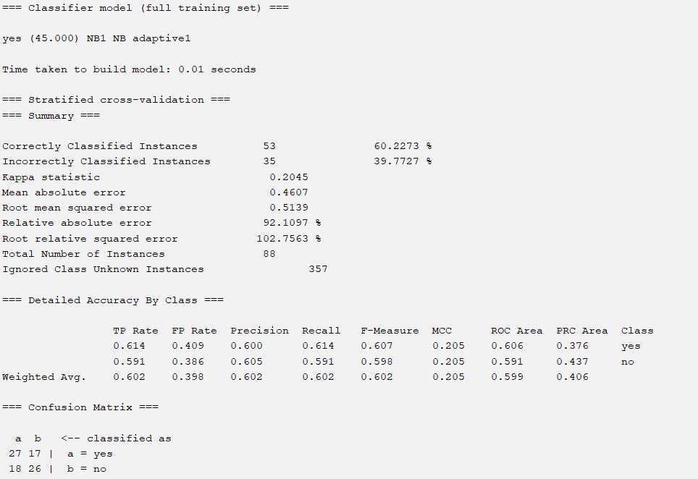

The model is an adaptive kernel-based Naive Bayes classifier. The accuracy on a stratified cross-validation test set was 60.2273%, and it was constructed in 0.01 seconds. The model accurately recognized 26 out of 35 negative examples (no) and 27 out of 53 positive instances (yes), according to the confusion matrix. With comparatively low accuracy and mistake rates, the overall performance is mediocre.

confusion Matrix

|  |  |  |
| --- | --- | --- |
| Classifie as | Yes(a) | No(b) |
| Actual Yes(a) | 27 | 17 |
| Actual No(b) | 18 | 26 |
|  |  |  |
|  |  |  |

Overview of the Model:

* Because of its remarkable 98.15% accuracy and ease of use, the Random Tree algorithm is the most effective of the models that were assessed. Random Tree is faster and more effective than more computationally demanding algorithms like Random Forest while yet achieving the same excellent classification performance. It is a great option for both large-scale and real-time applications because it strikes a compromise between precision, computing speed, and resource efficiency, resulting in low error rates and faultless categorization of negative cases (109/109).

# 

# Impact Analysis

* Social, health, safety, legal, and cultural aspects are all included in the research on the effects of social media use on mental health in computer science and engineering. Social media sites can both be resources for assistance and intervention and worsen mental health issues. Overuse of social media is associated with mental health problems, especially among vulnerable groups. Data security breaches, privacy violations, and cyberbullying are all safety concerns. Data security and the moral application of algorithms are legal concerns.Social media sites have advantages for mental health as well as disadvantages. They can promote a sense of community and give people access to resources, but they can also lead to detrimental effects on mental health, such as addiction, disinformation, and cyberbullying. A multifaceted strategy is needed for sustainable solutions, including platform regulation, mental health literacy education, digital literacy training, cooperative collaborations, and ongoing assessment. We may use social media to advance mental health by addressing stakeholder, societal, and environmental concerns.